28.1: For a charge with velocity 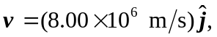 the magnetic field produced at a position away from the particle is 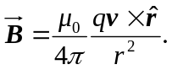 So for the cases below:
a) 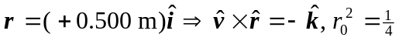
b) 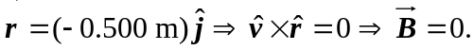
c) 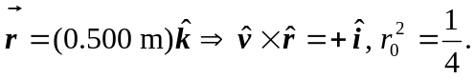
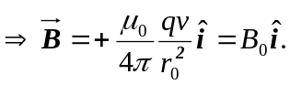
d) 